MICROCAPSULES OF PECTINE & ALGINATE FOR CELL ENTRAPMENT

Prepared by Luca Bilancetti

Dipartimento di Chimica e Tecnologia Farmaceutiche

Università degli studi di Perugia

Pg – 06123 Perugia

Italy

Cost 840 STSM
in the Laboratoire de Biotechnologie Chimique ( LBCh )

Institut des Sciences et Ingénierie Chimiques ( ISIC )

Facultè des Sciences de Base ( SB )

Ecole Polytechnique Fédérale de Lausanne ( EPFL )

Ch – 1015 Lausanne

Switzerland

Introduction

Knowing the properties of Pectine & Alginate ( biodegradable, biocompatible, non-toxic, non- immunoallergic ), the aim of the present work was to determin the technological parameters suited to obtain microcapsules from Pectine or Alginate using a droplet generator, with a air-driven jethead.

The influence of the type and concentration of biopolymers used, and the parameters of air-driven droplet generator, were analyzed.

Pectine and Alginate microcapsules, with diameters in the rabge of 350 to 500 µm were produced By Luca Bilancetti during the period 9-20 August 2004 under the superviosion of Christine Wandrey and with assistance of doctoral students of her group.

Materials

Pectine:
SKW Biosystems Unipectine OB 700

SKW Biosystems Unipectine OF 805

Medipol Pectin A2

Alginate:
Inotech Na-Alginate
Protanal Na-Alginate LF 20/40

Calcium chloride:
Fluka calcium chloride dihydrate

Methods

Microcapsules Preparation

The microcapsules were prepared with air-driven jethead system manufactured at the EPFL.
The solution of alginate or pectine, previously filtered with a ceramic filter porosity 2 corresponding to a pore size of 40–100µm, was loaded in a tube connected to a syringe pump and an air-driven droplet generator. Droplets fell into a calcium chloride solution that crosslinked the alginate to form gel microcapsules.
The following parameters were varied :

- The concentration of the polymer’s solution in the range of 1 to 4 % ( w/w ).
- The distance between the needle and the solution of calcium chloride in the range of 3 to 5 cm.
- The concentration of the calcium chloride’s solution in the range of 1 to 2 % ( w/w ).
- The Air Flow in the range of 3 to 6.

In total, 80 sets of microcapsules were prepared.
The mechanical stability for the capsules obtained was measured with a TA.XT2i Texture analyzer.
The mechanical deformation test were performed on capsules immersed in calcium chloride solution, at 0,05mm/s mobile probe speed, until bursting was observed. Twenty capsules per batch were analysed to obtain statistically relevant data.
From force vs. compression curves the compression works was calculated according to
W = ∫ F ds

Conclusion

The microcapsules of Pectine, produced with the air-driven jethead system, did not give good results. In fact the microcapsules don’t reflect the morphological features for cell entrapment. They are not spherical and present a lot of tails and coalescence.
The microcapsules produced with Alginate give optimal results and their morphological features are good.
The more resistant capsules of highest mechanical resistance were obtained using Protanal Na-Alginate LF 20/40.
By increasing the concentration for this type of Alginate we obtained a higher network density, yielding higher mechanical resistance.
The influence of :
- the concentration of the polymer’s solution
- the Air Flow
- the distance between the needle and the solution of calcium chloride
- the concentration of the Calcium Chloride’s solution
- the distance between head of the needle and the instrument

was found to be most significant for the microcapsule quality.
For the best micro beads product experimental details and results are presented in the attachment.

Legend
Height: the distance between the needle and the solution of Calcium chloride

Position :
A the distance between head of the needle and the instrument is 3mm.
B the distance between head of the needle and the instrument is 4mm.

Type of Polymer | [polymer] % | CaCl₂ Conc % | Air Flow | Rate of solution (ml/h) | height (cm) | size (µm)
Alginate LF 20/40 | 1,50 | 1,50 | 4,00 | 84 | 4 ( position B ) | ~ 350/400
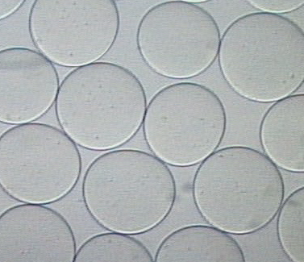 |  |  |  | 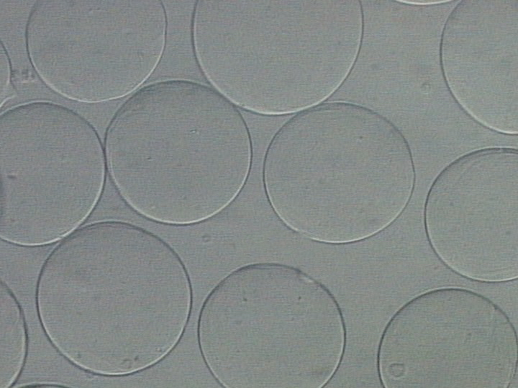
A

A texture analysis
Compression work = 21,67724

B

Type of Polymer | [polymer] % | CaCl₂ Conc % | Air Flow | Rate of solution (ml/h) | height (cm)  needle/bath | size (µm)
Alginate LF 20/40 | 1,50 | 2,00 | 4,00 | 84 | 4 ( position B ) | ~ 400/450
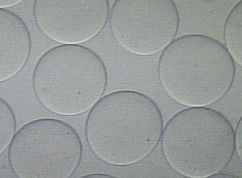 |  |  |  | 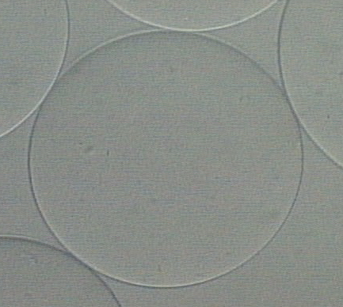

B texture analysis
Compression work = 24,77336

Type of Polymer | [polymer] % | CaCl₂ Conc % | Air Flow | Rate of solution (ml/h) | height (cm) | size (µm)
Alginate Inotech | 2,50 | 1,50 | 4,00 | 84 | 5 ( position A ) | ~ 550/600
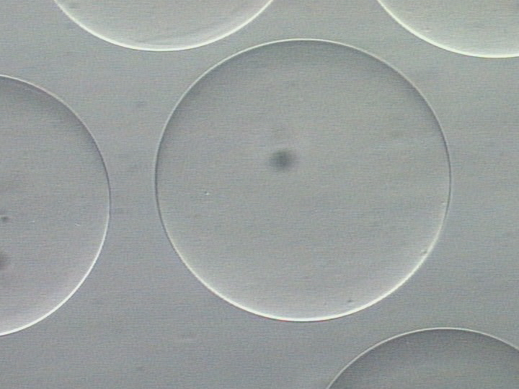 |  |  |  | 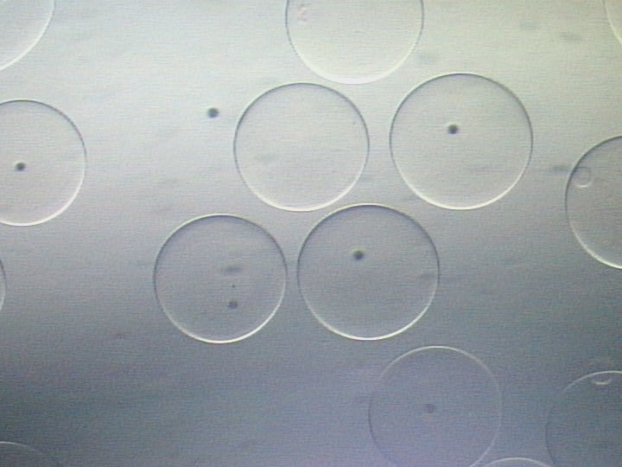
C

D
Type of Polymer | [polymer] % | CaCl₂ Conc % | Air Flow | Rate of solution (ml/h) | height (cm) | size (µm)
Alginate Inotech | 2,50 | 1,50 | 4,50 | 84 | 4 ( position A ) | ~ 400/450
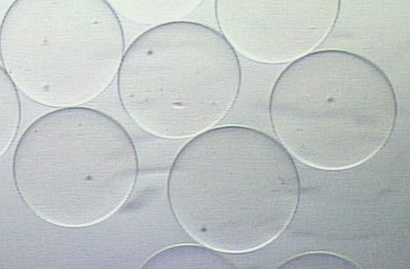 |  |  |  | 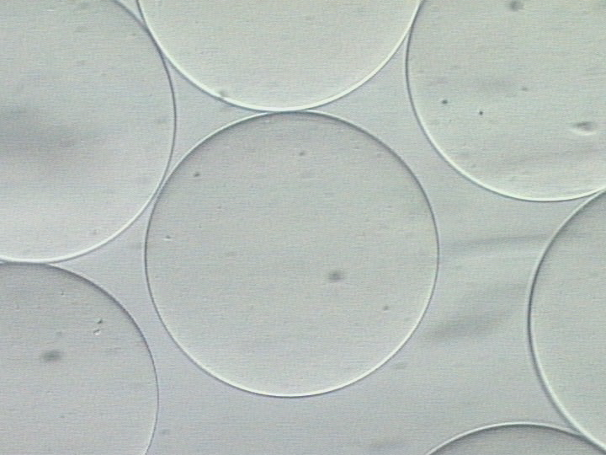

Bilancetti Luca

